

Conditional Statements

Dhruvin Dholiya



1. **Write a C program to find number is positive, negative or zero.**

* **Code**

#include<stdio.h>

int main() {

float num;

printf("Enter any number: ");

scanf("%f", &num);

if (num > 0) {

printf("%f is positive number.", num);

} else if (num < 0) {

printf("%f is nagative number.", num);

} else {

printf("%f isn't either positive or nagative number.", num);

}

return 0;

}

* **Output**

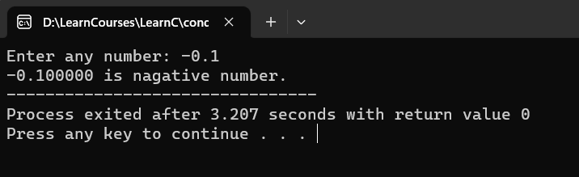

1. **Write a C program to find Grade from percentage. Here range is given below:**

* **91 - 100    A**
* **81 - <91    B**
* **71 - <81    C**
* **61 - <71    D**
* **40 - <61    E**
* **<40            Failed**
* **Code**

#include<stdio.h>

int main() {

float per;

printf("Please enter your percentage: ");

scanf("%f", &per);

if (per >= 91 && per <= 100) {

printf("Grade: A");

} else if (per >= 81 && per < 91){

printf("Grade: B");

} else if (per >= 71 && per < 81){

printf("Grade: C");

} else if (per >= 61 && per < 71){

printf("Grade: D");

} else if (per >= 40 && per < 61){

printf("Grade: E");

} else if (per >= 0 && per < 40){

printf("Sorry, you are feild in exam.");

} else {

printf("INVALID - please check your entered input.");

}

return 0;

}

* **Output**

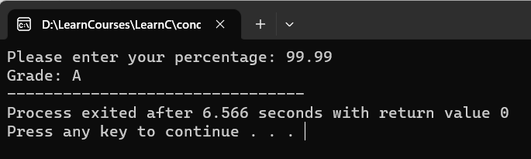

1. **Write a C program to find Code is alphabet, number or special symbols.**

* **Code**

#include<stdio.h>

int main() {

char x;

printf("Please enter Alphabet or Number or Symbol: ");

scanf("%c", &x);

if ((x >= 'a' && x <='z' ) || (x >='A' && x <='Z') ){

printf("%c is alphabate.", x);

} else if (x >= '0' && x <= '9') {

printf("%c is numbers.", x);

} else {

printf("%c isSpecial symbol.", x);

}

return 0;

}

* **Output**

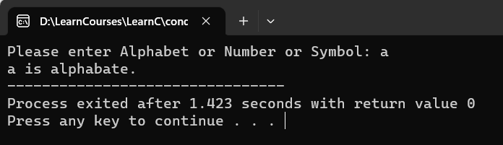

1. **Write a C program to compare two number.**

* **Code**

#include<stdio.h>

int main() {

int n1, n2;

printf("Please enter two number: ");

scanf("%d %d", &n1, &n2);

if (n1 < n2) {

printf("%d is less than to %d.", n1, n2);

} else if (n1 > n2) {

printf("%d is more than to %d.", n1, n2);

} else {

printf("%d is equal to %d", n1, n2);

}

return 0;

}

* **Output**

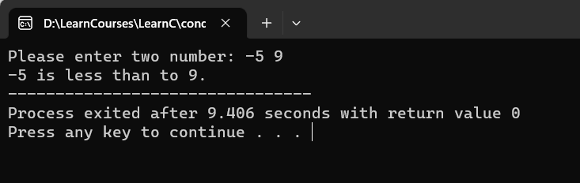

1. **Write a C program to find leap year.**

* **Code**

#include<stdio.h>

int main() {

int yr;

printf("Please add year: ");

scanf("%d", &yr);

if (yr < 0) {

printf("INVALID - entered year should be more then or equal to 0.");

} else if (yr % 400 == 0) {

printf("%d is leap year.", yr);

} else if (yr % 100 == 0) {

printf("%d is not leap year.", yr);

} else if (yr % 4 == 0) {

printf("%d is leap year.", yr);

} else {

printf("%d is not leap year", yr);

}

return 0;

};

* **Output**

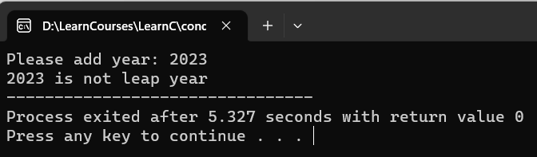

1. **Write a C program to Code electricity unit charges and calculate total electricity bill according to the given condition:**

For first 50 units Rs. 0.50/unit  
For next 100 units Rs. 0.75/unit  
For next 100 units Rs. 1.20/unit  
For unit above 250 Rs. 1.50/unit  
An additional surcharge of 20% is added to the bill.

* **Code**

#include<stdio.h>

int main() {

float unit, bill, totle_bill;

printf("Please enter totle unit of electricity bill: ");

scanf("%f", &unit);

if (unit >= 0) {

if (unit >= 0 && unit <= 50) {

bill = unit * 0.5;

} else if (unit > 50 && unit <= 150) {

bill = 50 * 0.5 + (unit - 50) * 0.75;

} else if (unit > 150 && unit <=250) {

bill = 50 * 0.5 + 100 * 0.75 + (unit - 150) * 1.2;

} else if (unit > 250) {

bill = 50 * 0.5 + 100 * 0.75 + 100 * 1.2 + (unit - 250) * 1.5;

}

totle_bill = unit + (unit * 0.2);

printf("Your bill: Rs. %f\n", bill);

printf("Your total electricity Bill: Rs. %f", totle_bill);

} else {

printf("INVALIDE - Added unit should be more than or equal to 0.");

}

return 0;

};

}

* **Output**

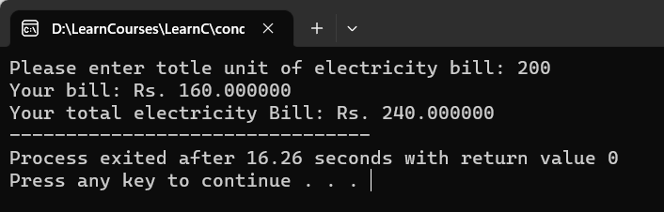

1. **Write a C program that ask your gender and salary and give bonus according to following criteria:**

* If you are male and your salary is less than 10000 than company will provide 2% bonus of your salary
* If you are female and your salary is less than 10000 than company will provide 3% bonus of your salary
* **Code**

#include<stdio.h>

int main() {

char gender;

int salary, bonus, totle_salary;

printf("Enter your gender M(male) or F(female) and salary: ");

scanf("%c %d", &gender, &salary);

if ((gender == 'm' || gender == 'M') && salary < 10000) {

bonus = salary * 0.2;

} else if ((gender == 'f' || gender == 'F') && salary < 10000) {

bonus = salary * 0.3;

}

totle_salary = salary + bonus;

if (salary < 10000 && salary > 0) {

printf("\nYour salary: Rs. %d/-\n", salary);

printf("Your bonus: RS. %d/-\n", bonus);

printf("Your totle_salary: Rs. %d/-", totle_salary);

} else if (salary < 0) {

printf("\nINVALID - Your salary should be more than or equal to 0.");

} else {

printf("\nSorry, Rs. %d is more than Rs.10000 so you can not get bonus.", salary);

}

return 0;

}

* **Output**

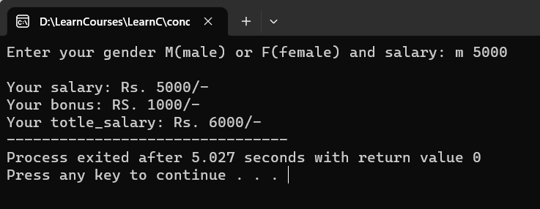

1. **Write a C program to calculate tax from given image.**

* **Code**

#include<stdio.h>

int main() {

int salary;

float tax_amt;

printf("Please enter your salary amount: ");

scanf("%d", &salary);

if (salary >= 0) {

if (salary > 2000 && salary <= 4000) {

tax_amt = 2000 * 0 + (salary - 2000) * 0.03;

} else if (salary > 4000 && salary <= 5000) {

tax_amt = 2000 * 0 + 2000 * 0.03 + (salary - 4000) * 0.05;

} else if (salary > 5000) {

tax_amt = 2000 * 0 + 2000 * 0.03 + 1000 * 0.05 + (salary - 5000) * 0.08;

}

if (salary > 2000) {

printf("Your salary: Rs. %d/-\n", salary);

printf("Tax amount: Rs. %f/-\n", tax_amt);

} else {

printf("No tax deducation.");

}

} else {

printf("INVALID - Please check your input.\n");

}

return 0;

}

return 0;

}

* **Output**

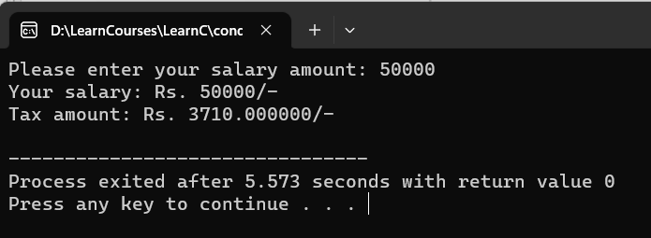

1. **Write a C program for calculate scholarship from given criteria:**

**Cast Criteria:**

* **Open: No Scholarship**
* **OBC: 25%**
* **SC: 50%**
* **ST: 100%**

**Grade Criteria:**

* **Your grade must be same or above B to eligible for scholarship.**

**Grade:**

* **A   (CGPA: 9+)**
* **B    (CGPA: 8.5+)**
* **C     (CGPA: 8+)**
* **D   (CGPA: 7.5+)**
* **Code**

#include<stdio.h>

int main() {

char cast, grade;

int fees, scholarship, totle_fees;

float cgpa;

printf("Enter your cast on based to given here.\n - O for Open\n - B for OBC\n - S for SC\n - T for ST\n Please enter your cast here: ");

scanf("%s", &cast);

printf("CGPA: ");

scanf("%f", &cgpa);

printf("Fees: ");

scanf("%d", &fees);

if (cgpa > 9 && cgpa <= 10) {

grade = 'A';

} else if (cgpa > 8.5 && cgpa <= 9) {

grade = 'B';

} else if (cgpa > 8 && cgpa <= 8.5) {

grade = 'C';

} else if (cgpa > 7.5 && cgpa <= 8) {

grade = 'D';

}

if (cast == 'O') {

printf("Sorry, Your cast is %c (Open) so you can not get Scholarship.", cast);

} else if (cast == 'B' && grade >= 'B') {

scholarship = fees * 0.25;

} else if (cast == 'S' && grade >= 'B') {

scholarship = fees * 0.50;

} else if (cast == 'T' && grade >= 'B') {

scholarship = fees * 1;

}

totle_fees = fees - scholarship;

printf("Your Fees is: Rs. %d/-\n", fees);

printf("Your CGPA is: Rs. %f/-\n", cgpa);

printf("Your scholarship is: Rs. %d/-\n", scholarship);

printf("Your Payable fees is: Rs. %d/-\n", totle_fees);

return 0;

}

* **Output**

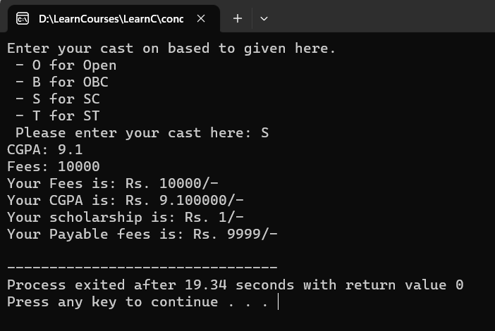

1. **Write a C program for calculate your net income from given criteria:**

* **If your net income is below 10000 you have not to pay any tax.**
* **If your net income is below 15000 you have to pay 10% tax.**
* **If your net income is above 15000 you have to pay 18% tax.**
* **Code**

#include<stdio.h>

int main() {

int income, mon_exp, net_income;

float tax;

printf("Income: Rs. ");

scanf("%d", &income);

printf("Monthly Expense: Rs. ");

scanf("%d", &mon_exp);

net_income = income - mon_exp;

if (net_income <= 10000) {

printf("You have not to pay any tax because your net incom is Rs. %d/-", net_income);

} else if ((net_income <= 15000) && (net_income > 10000)) {

tax = (net_income - 10000) * 0.1;

} else if (net_income > 15000) {

tax = 10000 * 0 + 5000 * 0.1 + (net_income - 15000) * 0.18;

}

if (net_income > 10000) {

printf("Your income is: Rs.%d/-\n", income);

printf("Your monthly mxpense is: Rs.%d/-\n", mon_exp);

printf("Your net income is: Rs.%d/-\n", net_income);

printf("Your playble tax amount is: Rs.%f", tax);

}

return 0;

}

* **Output**

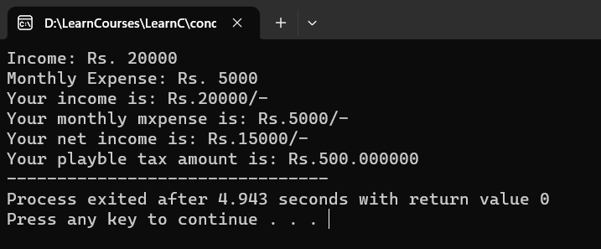

1. **Write a C program to find out maximum from 3 numbers using nested if.**

* **Code**

#include<stdio.h>

int main () {

float n1, n2, n3;

printf("Please enter any three numbers: ");

scanf("%f %f %f", &n1, &n2, &n3);

if (n1 > n2) {

if (n1 > n3) {

printf("%f is maximum", n1);

} else {

printf("%f is maximum", n3);

}

} else {

if (n2 > n3) {

printf("%f is maximum", n2);

} else {

printf("%f is maximum", n3);

}

}

return 0;

}

* **Output**

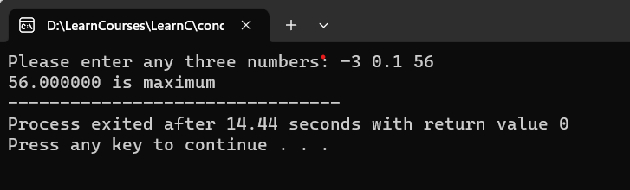

1. **Write a C program to find out maximum from 4 numbers using nested if.**

* **Code**

#include<stdio.h>

int main () {

float n1, n2, n3, n4;

printf("Please enter any four numbers: ");

scanf("%f %f %f %f", &n1, &n2, &n3, &n4);

if (n1 > n2) {

if (n1 > n3) {

if(n1 > n4) {

printf("%f is maximum", n1);

} else {

printf("%f is maximum", n4);

}

} else {

if(n3 > n4) {

printf("%f is maximum", n3);

} else {

printf("%f is maximum", n4);

}

}

} else {

if (n2 > n3) {

if (n2 > n4) {

printf("%f is maximum", n2);

} else {

printf("%f is maximum", n4);

}

} else {

if(n3 > n4) {

printf("%f is maximum", n3);

} else {

printf("%f is maximum", n4);

}

}

}

return 0;

}

* **Output**

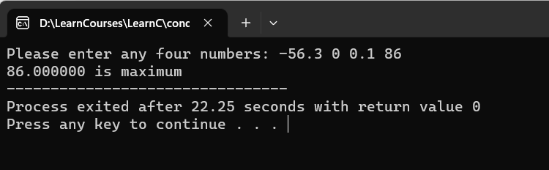

1. **Write a C program to find out minimum from 4 numbers using nested if.**

* **Code**

#include<stdio.h>

int main () {

float n1, n2, n3, n4;

printf("Please enter any four numbers: ");

scanf("%f %f %f %f", &n1, &n2, &n3, &n4);

if (n1 < n2) {

if (n1 < n3) {

if(n1 < n4) {

printf("%f is minimum ", n1);

} else {

printf("%f is minimum ", n4);

}

} else {

if(n3 < n4) {

printf("%f is maximum", n3);

} else {

printf("%f is maximum", n4);

}

}

} else {

if (n2 < n3) {

if (n2 < n4) {

printf("%f is minimum ", n2);

} else {

printf("%f is minimum ", n4);

}

} else {

if(n3 < n4) {

printf("%f is minimum ", n3);

} else {

printf("%f is minimum ", n4);

}

}

}

return 0;

}

* **Output**

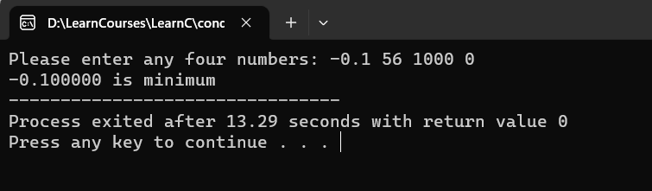

1. **Write a C program to find user is eligible for blood donation or not using nested if.**

* **Code**

#include<stdio.h>

int main () {

int age, weight;

printf("Age: ");

scanf("%d", &age);

if (age >= 18) {

printf("Weight: ");

scanf("%d", &weight);

if (weight >= 50) {

printf("You are able for blood donation.");

} else {

printf("Sorry, You are not able for blood donation beacuse your weight: %dKg is under to 50KG.",age, weight);

}

} else {

printf("Sorry, You are not able for blood donation beacuse your age: %d years is under to 18 years.", age);

}

return 0;

}

* **Output**

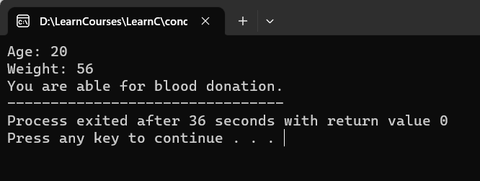

1. **Write a C program to calculate sales discount from given image using nested if or (switch case and if condition).**

* **code**

#include<stdio.h>

int main () {

char things;

int purchase_amt, discount;

printf("Please enter the type of things you purchased like: \n- M for mill cloths.\n- H for Handloom items.\n\nPlease enter here M or H: ");

scanf("%c", &things);

printf("amount of purchaed things: Rs. ");

scanf("%d", &purchase_amt);

if ((things == 'M' || things == 'm') && purchase_amt > 0 ) {

if (purchase_amt > 0 && purchase_amt <= 100) {

printf("Sorry, You can not get any discount.");

} else if (purchase_amt > 100 && purchase_amt <= 200) {

discount = purchase_amt * 0.05;

} else if (purchase_amt > 200 && purchase_amt <= 300) {

discount = purchase_amt * 0.075;

} else if (purchase_amt > 300) {

discount = purchase_amt * 0.1;

}

printf("\nCoungrats, You get discount: Rs.%d", discount);

} else if ((things == 'H' || things == 'h') && purchase_amt > 0 ) {

if (purchase_amt > 0 && purchase_amt <= 100) {

discount = purchase_amt * 0.05;

} else if (purchase_amt > 100 && purchase_amt <= 200) {

discount = purchase_amt * 0.075;

} else if (purchase_amt > 200 && purchase_amt <= 300) {

discount = purchase_amt * 0.1;

} else if (purchase_amt > 300) {

discount = purchase_amt * 0.15;

}

printf("\nCoungrats, You get discount: Rs.%d/-", discount);

} else {

printf("INVALID - Please check your added input");

}

return 0;

}

* **Output**

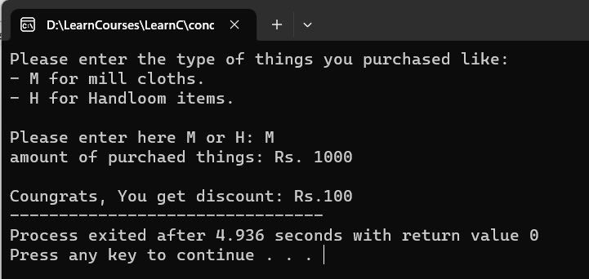

1. **Reform 9th program using nested if**.

* **Code**

#include<stdio.h>

int main() {

char cast, grade;

int fees, scholarship, totle_fees;

float cgpa;

printf("Enter your cast on based to given here.\n - O for Open\n - B for OBC\n - S for SC\n - T for ST\nPlease enter your cast here: ");

scanf("%s", &cast);

if (cast == 'O') {

printf("Sorry, Your cast is %c (Open) so you can not get Scholarship.", cast);

} else if (cast == 'B' || cast == 'S' || cast == 'T') {

printf("CGPA: ");

scanf("%f", &cgpa);

if (cgpa > 9 && cgpa <= 10) {

grade = 'A';

} else if (cgpa > 8.5 && cgpa <= 9) {

grade = 'B';

} else if (cgpa > 8 && cgpa <= 8.5) {

grade = 'C';

} else if (cgpa > 7.5 && cgpa <= 8) {

grade = 'D';

}

if (grade >= 'B') {

printf("Fees: ");

scanf("%d", &fees);

if (cast == 'B') {

scholarship = fees * 0.25;

} else if (cast == 'S') {

scholarship = fees * 0.50;

} else if (cast == 'T') {

scholarship = fees * 1;

}

totle_fees = fees - scholarship;

printf("\nYour Fees : Rs. %d/-\n", fees);

printf("Your CGPA is: %f\n", cgpa);

printf("Your Scholarship: Rs. %d/-\n", scholarship);

printf("Your Payable fees: Rs. %d/-\n", totle_fees);

} else {

printf("Sorry, Your CGPA should more than 8.5+ and less than or euqal to 10.");

}

} else {

printf("INVALID - Please check your added input.");

}

return 0;

}

* **Output**

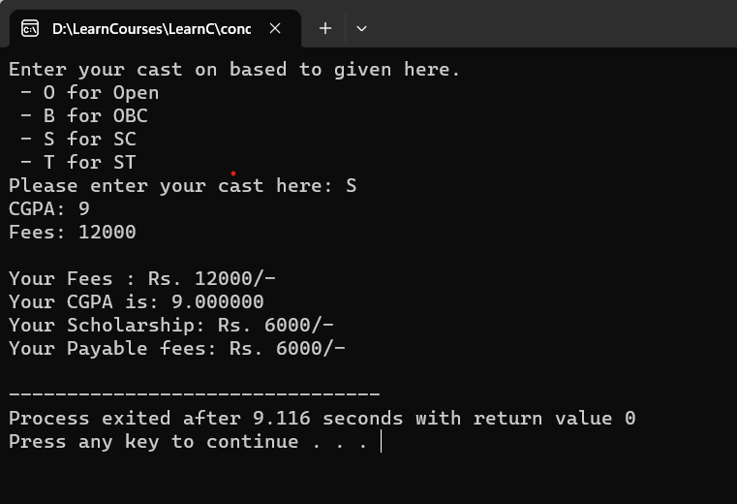

1. **Write a C program to find day name using switch case.**

* **Code**

#include<stdio.h>

int main () {

char day;

printf("Enter the first letter of day: ");

scanf("%c", &day);

switch (day) {

case 'M':

printf("Monday");

break;

case 'T':

printf("Tuseday");

break;

case 'W':

printf("Wendsday");

break;

case 't':

printf("Thursday");

break;

case 'F':

printf("Friday");

break;

case 'S':

printf("Saterday");

break;

case 's':

printf("Sunday");

break;

default:

printf("\nINVALID - Please check your added input.");

break;

}

return 0;

}

* **Output**

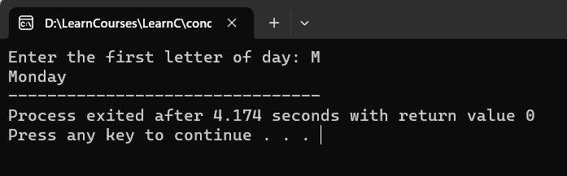

1. **Write a C program to find month name from month number using switch case.**

* **Code**

#include<stdio.h>

int main () {

int month;

printf("Enter month number: ");

scanf("%d", &month);

switch (month) {

case 1:

printf("January");

break;

case 2:

printf("February");

break;

case 3:

printf("March");

break;

case 4:

printf("April");

break;

case 5:

printf("May");

break;

case 6:

printf("June");

break;

case 7:

printf("July");

break;

case 8:

printf("August");

break;

case 9:

printf("September");

break;

case 10:

printf("Octomber");

break;

case 11:

printf("November");

break;

case 12:

printf("December");

break;

default:

printf("INVALID - Please check your added input.");

break;

}

return 0;

}

* **Output**

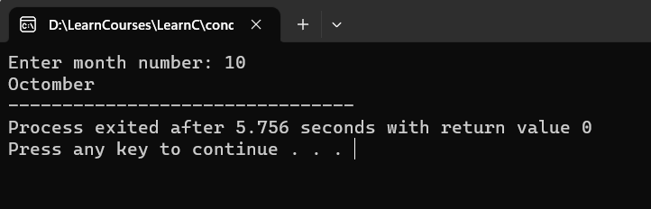

1. **Reform 7th program using switch case and if condition.**

* **Code**

#include<stdio.h>

int main() {

char gender;

int salary, bonus, totle_salary;

printf("Enter your gender M(male) or F(female): ");

scanf("%c", &gender);

switch (gender) {

case 'M':

printf("Enter your salary: Rs. ");

scanf("%d", &salary);

if (salary < 10000 && salary > 0) {

bonus = salary * 0.2;

totle_salary = salary + bonus;

printf("Your salary: Rs. %d/-\n", salary);

printf("Your bonus: RS. %d/-\n", bonus);

printf("Your totle_salary: Rs. %d/-", totle_salary);

} else {

printf("\nSorry, You can not get bonus because your salary should more than Rs.0/- otherwise less than Rs.10000/-.");

}

break;

case 'F':

printf("Enter your salary: Rs. ");

scanf("%d", &salary);

if (salary < 10000 && salary > 0) {

bonus = salary * 0.3;

totle_salary = salary + bonus;

printf("Your salary: Rs. %d/-\n", salary);

printf("Your bonus: RS. %d/-\n", bonus);

printf("Your totle_salary: Rs. %d/-", totle_salary);

} else {

printf("\nSorry, You can not get bonus because your salary should more than Rs.0/- otherwise less than Rs.10000/-.");

}

break;

default:

printf("\nINVALID - Please check your added input.");

break;

}

return 0;

}

* **Output**

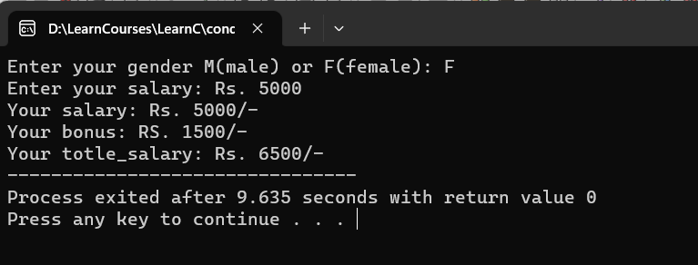

1. **Write a program to check whether a given number is divisible by 5 or not.**

* **Code**

#include<stdio.h>

int main() {

int num;

float ans;

printf("Please Enter any number: ");

scanf("%d", &num);

if (num % 5 == 0) {

printf("%d number is divisible by 5.", num);

} else {

printf("%d number is not divisible by 5.", num);

}

return 0;

}

* **Output**

